100m sprint times

Purpose:
Students will investigate the progression of 100m sprint world record times since the start of the 20th century.

Achievement objectives:
NA6-7 Relate graphs, tables, and equations to linear, quadratic, and simple exponential relationships found in number and spatial patterns.
NA6-8 Relate rate of change to the gradient of a graph.
S6-1 Plan and conduct investigations using the statistical enquiry cycle:
- identifying and communicating features in context (trends, relationships between variables, and differences within and between distributions), using multiple displays
- justifying findings, using displays and measures.

Indicators:
- Makes connections between representations such as number patterns, spatial patterns, tables, equations and graphs.
- Identifies and uses key features including gradient, intercepts, vertex, and symmetry.
- Calculates average rate of change for the given data.
- Relates average rates of change to the gradient of lines joining two points on the graph of linear, quadratic, or exponential functions.

Specific learning outcomes:
Students will be able to:
- plot points and spot trends in the progression of 100m sprint times.
- question, validate and critique the data they are using.
- describe what is happening in particular time segments to the 100m sprint times, for example, statements like “the world record time is reducing by x seconds per y time period”

Diagnostic snapshot(s):
Students plot (x,y) coordinates using suitable linear scale
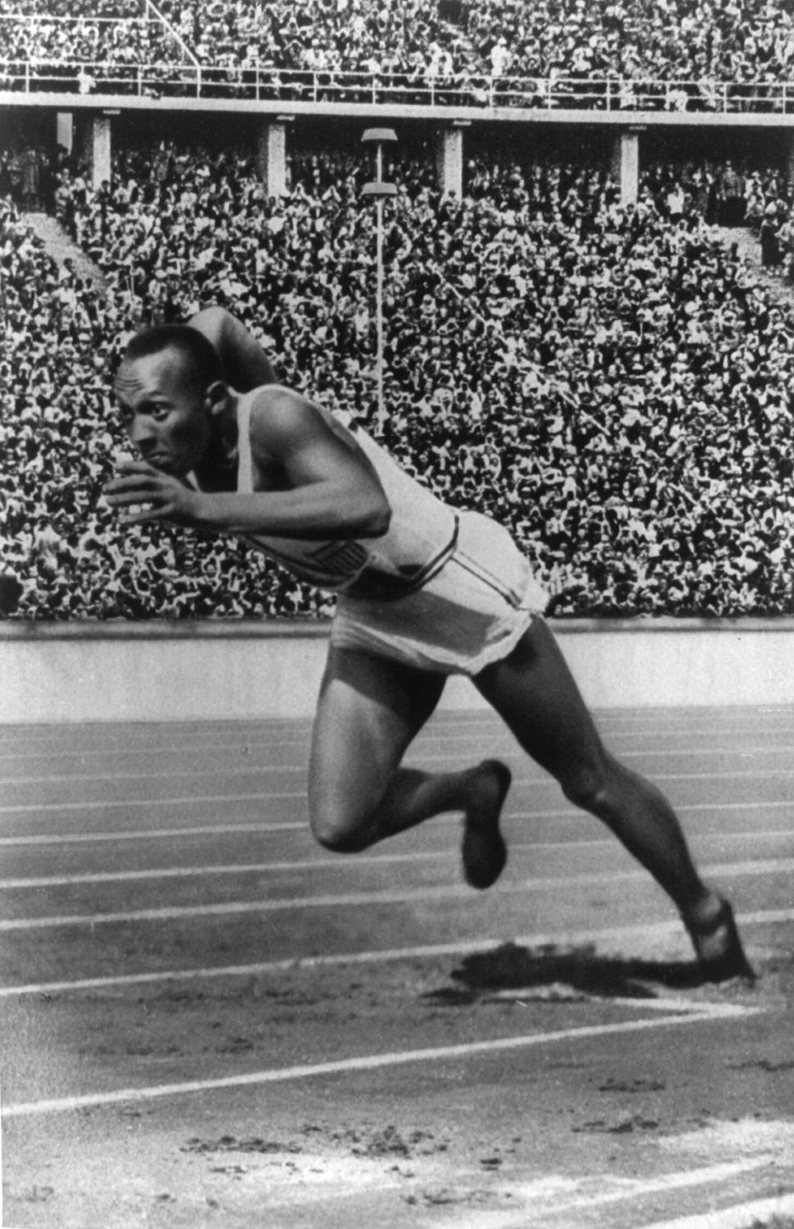
x y
2 15
5 19
6 22
15 30
25 55

Planned learning experiences:
Source 100m world record times and provide these for students (or get the students to source them from the Internet).

Students plot the 100m times and join the points and then a ‘best fit’ curve.
Students investigate the data by asking questions such as:
What’s the overall trend?
What could happen eventually with the 100m sprint times?
What is more likely to happen? How can we ‘prove’ this?
What are the differences between men’s and women’s ‘curves’?
Using decade long periods, by how much do the times reduce on average?

Other investigations include:
- Students plotting the differences to see the non-linearity of the progression.
- Equation of line of best fit (linear) and using this to interpolate and extrapolate by using substitution.

Possible adaptations to the activity:
- There is scope to introduce non linear curves.
- Use of difference scales and investigate the non-changing gradient but perhaps different conclusions (“the eyes have it”).
- Investigate other sports whose progression is characterised by other ‘decreases’ over time (skiing, marathon, …) or increases (long jump, highest cricket test score,…).

- Students could run 100m and compare their times with the early 20th century times.

Cross curricular links:
There is a strong link to history (for example, Jesse Owens 1936) and physical education (the anatomical reasons behind the progression of 100m sprint times).

Planned assessment:
This teaching and learning activity could lead towards assessment in the following achievement standards.
1.3 Investigate relationships between tables, equations or graphs

Spotlight on:
Pedagogy:
- Encouraging reflective thought and action
  - Supporting students to explain and articulate their thinking
- Making connections to prior learning and experience
  - Checking prior knowledge using a variety of diagnostic strategies
- Teaching as inquiry
  - What are next steps for learning?

Key Competencies:
- Thinking
  - Students explore and use patterns and relationships in data and they predict and envision outcomes
- Using language, symbols and text
  - Students interpret visual representations such as graphs
- Managing self
  - Students develop skills of independent learning

Values and principles:
Students will be encouraged to value innovation, inquiry, and curiosity, by thinking critically, creatively, and reflectively.

Maori/Pasifika
Ka Hikitia <http://www.minedu.govt.nz/theMinistry/PolicyAndStrategy/KaHikitia/TheirVoice/Educators.aspx >
Compass for Pasifika success <http://www.minedu.govt.nz/NZEducation/EducationPolicies/PasifikaEducation/PasifikaEducationPlan/CompassForPasifikaSuccess.aspx >

Planning for content and language learning:
Link to ESOLonline <http://esolonline.tki.org.nz/ESOL-Online/Student-needs/Planning-for-learning/Principles-of-effective-teaching-and-learning-for-English-language-learners>

Links:
Men’s sprint times
<http://en.wikipedia.org/wiki/World_record_progression_100_metres_men >
Women’s sprint times
<http://en.wikipedia.org/wiki/World_record_progression_100_metres_women >
Suggested best models for 100m sprint times
<http://www.condellpark.com/kd/sprintlogistic.htm#trendingaverages >

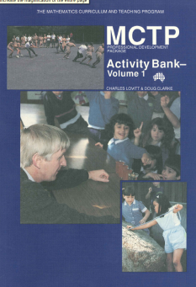
Connections:
Lovitt, C., & Clarke, D. (1992). MCTP Professional Development Package: Activity Bank Volume 1. Carlton, Victoria: Curriculum Corporation
- Snippets (page 31)

